Section 508 Testing for:

VCampus Corporation

Prepared By:



18122 Vontay Road
Rockville, VA 23146
Voice: (804) 749-8646
Fax: (804) 749-4585
www.TecAccess.net
Table of Contents
Understanding the TecAccess Reports 4
Executive Summary 4
Accessibility Report 4
Methods and Criteria 6
Executive Summary 7
Results per 1194.22 Web-based Intranet and Internet Information and Applications 7
Color 7
Results Regarding the Web Content Accessibility Guidelines (WCAGs) 8
Results Regarding Usability 9
Conclusion 9
Accessibility Report 10
Site-Wide Issues 10
Login 14
Registration 14
The graphic “cx_calendar.gif.” 15
Calendar 17
Cameo Student Home Page 20
Cameo Student Feedback 23
Cameo Student Logout Page 24
Current Learning Modules 25
My Training 25
Records/Transcripts 26
Add External Record 27
Personal Calendar 28
Personal Notebook 29
Catalog/Search 31
Catalogs Page 32
Default Public Catalog 34
News Search 38
Know Your Colleague 39
Communicate 40
Discussion Forum 40
Send A Message 42
Select To Recipients 43
Mailbox 45
Personal Profile 46
Biography 47
Change Password 48
VPAT 49
Supporting Features (second column on VPAT) 49
1194.22 Web-based Internet information and applications 50

Understanding the TecAccess Reports

Executive Summary

The Executive Summary is a preview of the main points of our testing results; its goal is to provide a condensed version of the longer report's content. This report should help determine the key results of our findings.

Accessibility Report

The Accessibility Report is a compilation of explanations of Section 508 and Worldwide Web Consortium (W3C) standards that specifically pertain to the testing of your product. Each explanation offers techniques on how the standard can be applied and provides specific examples that are taken from our test cases on your product.

Accessibility Reports document Section 508 and WCAG issues. Additionally, we generally offer usability recommendations as a by-product of our assessments and audits. These issues are broken down into two categories:

Section 508 Standards
All Section 508 issues are considered critical. Therefore, they must be remediated to achieve compliance with the Section 508 Technical Standards.

Priority Levels of the W3Cs Web Content Accessibility Guidelines (WCAGs)

Priority 1 (P1)
A Web content developer must satisfy this checkpoint; otherwise, one or more groups will find it impossible to access information in the document. Satisfying this checkpoint is a basic requirement for some groups to be able to use Web documents.

Priority 2 (P2)
A Web content developer should satisfy this checkpoint; otherwise, one or more groups will find it difficult to access information in the document. Satisfying this checkpoint will remove significant barriers to accessing Web documents.

Priority 3 (P3)
A Web content developer may address this checkpoint; otherwise, one or more groups will find it somewhat difficult to access information in the document. Satisfying this checkpoint will improve access to Web documents.

*Some checkpoints specify a priority level that may change under certain (indicated) conditions.

Some similarities exist between the Technical Standards of Section 508 and the Checkpoints of the WCAGs. However, significant differences between the two types of guidelines also appear.

Jim Thatcher’s “Side by Side Comparison” provides some assistance:

From the WCAG View:
If a web site is 508-compliant and its author wants to be Web Accessibility Initiative A-Compliant as well, these are the only four checkpoints (1.3, 4.1, 6.2, and 14.1) he must address additionally.

From the Section 508 View:
If a web site is WCAG A-Compliant and its author wants to be Section 508 compliant as well, these are the five standards he must address additionally. These are paragraphs 1194.22 (l), (m), (n), (o), and (p).

Methods and Criteria

Product Information:
Diagnostic testing and validation was performed on the VA CAMEO site at http://www.vcampus.com/cameo/. Testing was focused on the Section 508 web standards [1194.22] and the W3C’s WCAG checkpoints.

Testing Note
At the time of testing, the Help page available through the Help link on the Cameo Student Home Page was not available. The link gave a 404 page not found error. Thus this page was omitted from the review.

AT/Testing Tools:
Assistive technologies (AT) and methods were used that include JAWS v6.2, ZoomText 8.0 (magnifier), and non-mouse access via keyboard.

Testing Criteria:
- 1194.22 (Web-based Intranet and Internet Information and Applications).
- Web Content Accessibility Guidelines (WCAGs) v1.0 (Priority 1, 2, and 3).
- General accessibility/usability.

Executive Summary

The following issues are critical to achieving compliance, and are in a descending order loosely based on frequency of occurrence and overall impact:

Results per 1194.22 Web-based Intranet and Internet Information and Applications

Text Equivalents
Most images have Alt attributes. There are a few decorative images that have no Alt attributes and they need blank Alt attributes to be added. There also are some graphics that are part of a text link which are serving as decoration, that have assigned Alt attributes but instead should have empty Alt attributes. In this case the assigned Alt attribute is the same as the link’s text, and this causes screen readers to repeat the text of the link twice. Finally, throughout the site, the Calendar icon link that is used to display the calendar does not have an Alt attribute.

CSS/Readability
CSS is used to control layout and presentation. Information is presented in a logical order when style sheets are disabled or unsupported. The use of user-defined style sheets is also supported. However, some structural markup such as heading tags for text headings and column/row headings in data tables is missing.

Color
Color does not convey meaning on most pages. The notable exception is when color alone conveys the current day’s date in the Calendar.

Tables
Many layout tables are present that are in a logical, linear order. As mentioned above, some data tables lack structural markup, such as TH tags for headings. Data tables often have other text or buttons appearing in the first row of the table with the data’s headings then appearing in the second row; it is recommended to place headings in the first row of the table. If other information needs to be displayed, place it above the table, or in the table’s caption.

Forms
Forms are keyboard accessible. Implicit association of labels with their respective controls works the majority of the time when tested using JAWS. However, explicit labeling using the Label For syntax is missing for all form elements. At times edit fields are disabled and only used to display information. The disabling of these controls makes it difficult for screen reader users to review the contents of these edit fields when navigating a form with the tab key. A better approach is to set these edit fields that are not to be edited directly to a read-only status. Finally, the arrow buttons used in the selecting of recipients to send mail to on the “Select Recipients” page are not screen reader friendly; the captions are not intuitive or logical to a screen reader user.

Navigation Link Skipping
Skipping the Navigation frame using the browser’s method of frame skipping via keyboard is possible. However, no “skip nav” mechanism inside the Navigation (top left) frame is found.

Frames
The frames lack Title attributes. Screen readers use the Title attributes to identify the frame to the user. Some of the frames have title tags, which is good: these are also necessary. More frames need them however. Additionally, the frames need descriptive titles. Often the main content frame has a generic title that does not tell the user where he is in the system. Headings are present in the main frame that gives the identifying information, which is very helpful. However, it would be good to add the same heading information to the frame’s title.

Results Regarding the Web Content Accessibility Guidelines (WCAGs)

Structural Elements
Many pages contain structural elements. Headings are used throughout the site, which is great. However, there are instances of text meant to be a heading that is not yet included in a heading element. Along with this, there are instances where items are listed, but without being included in a list element. And one screen was found to have a broken list element.

Tab Navigation and AccessKeys
The site can be used via the keyboard; the tab key can reach the areas the user needs to use. The use of disabled edit fields instead of read-only edit fields precludes screen reader users of being able to review their contents while tabbing; read-only edit fields are recommended instead of disabled ones. Some combo boxes do have onChange event handlers, which can be triggered easily via the keyboard if the user is not aware of the event handler. However, the Alt+Down arrow keystroke does work to make a keyboard selection in these combo boxes as it should. Of final note, none of the main navigational links have accesskeys assigned to them. While not a requirement, their use can be helpful for keyboard-only users.

Results Regarding Usability
The site’s usability is good. At times, the website seems to open a lot of extra windows, which can be a bit confusing.

Conclusion

Overall, the VA CAMEO website is accessible. However, some remediation is necessary to achieve compliance with the Section 508 Technical Standards and conformance with the Web Content Accessibility Guidelines.

We look forward to assisting with the goal of achieving compliance, conformance, and accessibility. Please feel free to contact us for further clarification or explanation.

Accessibility Report

Site-Wide Issues

The following test results are site-wide issues that pertain to all pages.

Section 508

1194.22(a) A text equivalent for every non-text element shall be provided (e.g., via "alt", "longdesc", or in element content).
Decorative graphics sometimes do not have any Alt attributes assigned, while descriptions, such as for graphics included along with a text link, are assigned at other times. Text equivalents for decorative-exclusive graphics are undesired.
The Alt attributes used for the navigation links: “Current news, your courses, and other items of interest”, “Your transcript, training plan, and other learning records”, “Search for courses, programs, certifications, people and news”, “The discussion forum, e-mail, message board, and other collaborative services”, and “Change your preferences, language, and password” is too verbose and does not say the same thing that the text on the graphics say.

Recommendation
A decorative graphic should be assigned an empty Alt attribute (ALT=””). The technique prevents screen readers from reading extra verbiage that is not necessary for the user to read.
Images that convey meaning when the meaning is not available elsewhere, e.g., the calendar icon, need to have appropriate Alt attribute text.
Where images display text such as for the noted navigational links, set the Alt attribute text equivalently to the text displayed.

1194.22(d) Documents shall be organized so they are readable without requiring an associated style sheet.
Headings are used throughout the website. Many, but not all, are contained in heading tags. Heading tags such as H1, H2, H3, etc., are desirable for all headings. This ensures that document structure is maintained if style sheets are disabled or not supported. Additionally, this structure assists screen reader users whose assistive technology often has special commands to quickly review and navigate a web page that contains headings.

Recommendation
Add heading tags for each text element that is meant to be viewed as a heading.

1194.22(i) Frames shall be titled with text that facilitates frame identification and navigation.
The frames lack Title attributes. Screen readers use the Title attributes to identify the frame to the user. Some of the frames have a title tag, which is good; these are needed along with the Title attributes. Often the main content frame has a generic title that does not tell the user where heis in the system. While headings are present in the main frame that gives the identifying information, the same heading information is not present in the frame’s title.

Recommendations
Use Title attributes for the frames. For example, for the top left frame containing navigational links, a Title attribute of “Navigation” would be helpful. Also set the Title tags (<TITLE> </TITLE>) in the frames to what the frame is. For the main content frame, set it equal to what the headings display.

1194.22(n) When electronic forms are designed to be completed on-line, the form shall allow people using assistive technology to access the information, field elements, and functionality required for completion and submission of the form, including all directions and cues.
Not all forms on the VA Cameo website have explicit labeling using the Label For syntax. When explicit labeling is not used, assistive technology such as screen readers must rely on implicit association of labels with their controls, which is based upon position. Implicit association worked fairly well on the site in conjunction with JAWS. However, explicit labeling is needed to ensure that all assistive technologies will work correctly, as well as to conform to the latest standards.
In some instances, edit fields are used to show the current setting for some things, such as a date where an additional wizard needs to be used to actually change the value. The majority of these edit fields are disabled instead of being set to read-only. Disabling the control causes for it to be bypassed in the tab order; thus screen reader users who use tab to review a form’s fields and content will miss this information and not be able to access it.

Recommendations
Add explicit labels using the Label For syntax to all controls including edit fields, radio buttons, checkboxes, combo boxes and text areas.
Use read-only controls instead of disabled controls to display information that is meant to not be edited directly.

1194.22(o) A method shall be provided that permits users to skip repetitive navigation links.
A “skip nav” mechanism is not present on the VA Cameo website. It is possible to skip around the page between frames by using the browser’s built in frame skipping mechanism, which is a start.

Recommendation
Add a “skip nav” to the top left frame that contains navigational links. If possible, have the skip nav move directly to the content of the main frame. If this is not possible, then placing focus after the last link in the navigation frame is sufficient.

WCAG Checkpoints

1.1 (Priority 1) Provide a text equivalent for every non-text element (e.g., via "alt", "longdesc", or in element content). This includes: images, graphical representations of text (including symbols), image map regions, animations (e.g., animated GIFs), applets and programmatic objects, ascii art, frames, scripts, images used as list bullets, spacers, graphical buttons, sounds (played with or without user interaction), stand-alone audio files, audio tracks for video, and video.
Comparable to 1194.22(a) above.

3.5 (Priority 2) Use header elements to convey document structure and use them according to specification.
Comparable to 1194.22(d) above.

3.6 (Priority 2) Mark up lists and list items properly.
Comparable to 1194.22(d) above.

9.5 (Priority 3) Provide keyboard shortcuts to important links (including those in client-side image maps), form controls, and groups of form controls.
No accesskeys are provided.

Recommendation
Adding accesskeys to the navigational links in the top left frame and to other regularly used links would be helpful for keyboard-only users.

12.1 (Priority 1) Title each frame to facilitate frame identification and navigation.
Comparable to 1194.22(i) above.

12.4 (Priority 2) Associate labels explicitly with their controls.
Comparable to 1194.22(n) above.

Login
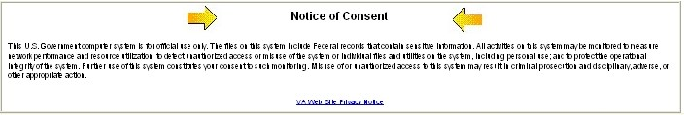Notice of Consent Heading

Section 508

1194.22(d) Documents shall be organized so they are readable without requiring an associated style sheet.
A heading tag is missing for “Notice of Consent.”

Recommendation
Place the text inside of a heading tag.

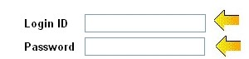
Edit fields

1194.22(n) When electronic forms are designed to be completed on-line, the form shall allow people using assistive technology to access the information, field elements, and functionality required for completion and submission of the form, including all directions and cues.
The edit fields lack explicit labeling.

Recommendation
Add explicit labels to this form using the Label For syntax.

WCAG Checkpoints

Checkpoint 3.5 (Priority 2) applies, comparable to 1194.22(d) above.

Checkpoint 12.4 (Priority 2) applies, comparable to 1194.22(n) above.

Registration

The graphic “cx_calendar.gif.”

Section 508

1194.22(a) A text equivalent for every non-text element shall be provided (e.g., via "alt", "longdesc", or in element content).
On the Self Registration page (first screen) and elsewhere in the registration process, the calendar graphic cx_calendar.gif does not have an Alt attribute.

Recommendation
Add an Alt attribute of “Calendar” or similar to the image tag.

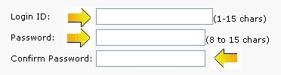
Text Edit boxes
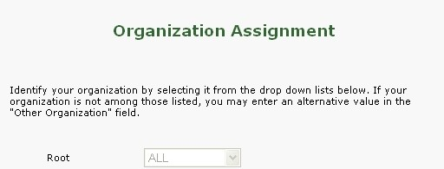
Combo Box

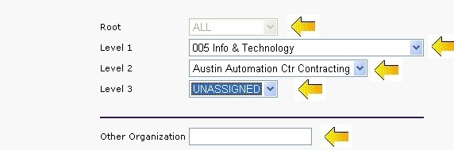
Combo boxes and Text Edit fields on one of the Registration pages.

Checkbox on the “Self Registration” page

1194.22(n) When electronic forms are designed to be completed on-line, the form shall allow people using assistive technology to access the information, field elements, and functionality required for completion and submission of the form, including all directions and cues.
All form input elements including text boxes, combo boxes, radio buttons and checkboxes lack explicit labeling to associate labels with controls.

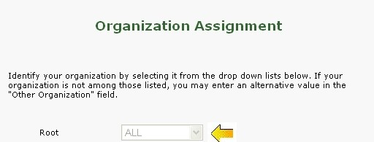
The “Root” combo box that is disabled.

On the Organization Assignment page (first screen), the Root combo box is disabled.

The “Date of Birth” field is disabled.

On the Self Registration page, the “Date of birth” field is disabled instead of set to read-only.

Recommendations
Add explicit labeling to all of the form controls throughout the registration process. Where radio buttons are present, group each set of radio buttons with a Fieldset element.
Organization Assignment: If the Root combo box is not meant to be changed, set it to read-only.
Self Registration (first screen): Set the “Date of birth” edit field to read-only instead of disabled, so its contents can be reviewed by screen reader users as they tab.

WCAG Checkpoints

Checkpoint 1.1 (Priority 1) applies, comparable to 1194.22(a) above.

Checkpoint 12.4 (Priority 2) applies, comparable to 1194.22(n) above.

Calendar
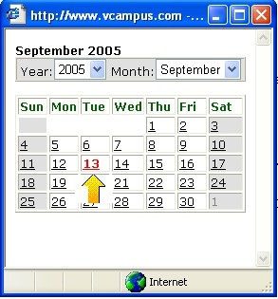
The date is shown is the color “Red”.

Section 508

1194.22(c) Web pages shall be designed so that all information conveyed with color is also available without color, for example from context or markup.
The current date is indicated in the table by displaying it in red. No text equivalent is present.

Recommendation
Provide a text equivalent for the color coding. Examples include placing an asterisk by the current date, or noting it elsewhere on the web page.

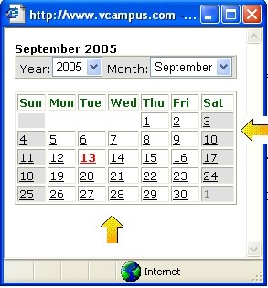
The table itself is lacking TH tags.

1194.22(g) Row and column headers shall be identified for data tables.
The table containing the actual calendar display lacks TH tags for the headings which are the days of the week.

Recommendation
Add TH tags and place the column heading row in a THEAD element.

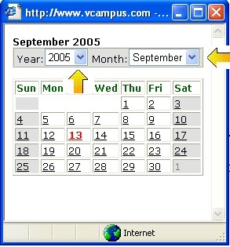
The combo boxes do not have explicit labels.

1194.22(n) When electronic forms are designed to be completed on-line, the form shall allow people using assistive technology to access the information, field elements, and functionality required for completion and submission of the form, including all directions and cues.
The combo boxes do not have explicit labels to associate them with the text labels.

Recommendation
Add the explicit labeling using the Label For syntax.

WCAG Checkpoints

Checkpoint 2.1 (Priority 1) applies, comparable to 1194.22(c) above.

Checkpoint 5.1 (Priority 1) applies, comparable to 1194.22(g) above.

Checkpoint 12.4 (Priority 2) applies, comparable to 1194.22(n) above.

Cameo Student Home Page
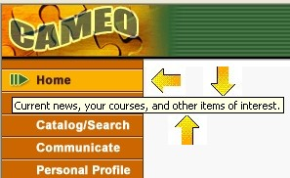
The “Home” alt tag

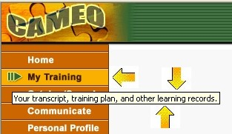
The “My Training” alt tag

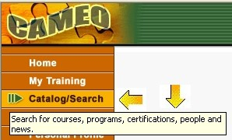
The “Catalog/Search” alt tag

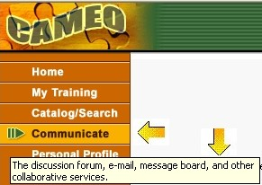
The “Communicate” alt tag

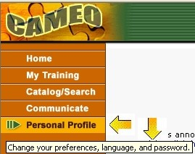
The “Personal Profile” alt tag


The “Homeheading"gif”

Section 508

1194.22(a) A text equivalent for every non-text element shall be provided (e.g., via "alt", "longdesc", or in element content).
The Alt attributes assigned to the links “Home,” “My Training,” “Catalog/Search,” “Communicate” and “Personal Profile” at the top left of this page do not match the text that the graphics display. The Alt attribute text is verbose, but it is not equivalent to displayed text.
The graphic homeheading.gif does not have an Alt attribute.
Recommendation
Change the Alt attribute text for these graphics and set it to match the displayed text. And add an Alt attribute to the homeheading.gif image.

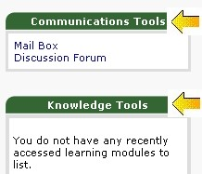
The headings “Communications Tools” and “Knowledge Tools”

1194.22(d) Documents shall be organized so they are readable without requiring an associated style sheet.
The headings “Communications Tools” and “Knowledge Tools” are not encapsulated in heading tags.
The groups of links that correspond to a section are not currently grouped together.

Recommendation
Add a heading tag such as an H1, H2, etc., for the headings.
For grouping the links, place each set of links inside of a list element. This gives grouping and assists with document structure.

1194.22(i) Frames shall be titled with text that facilitates frame identification and navigation.
The titles of the frames are not distinct. It appears that the frame title attributes are not set.

Recommendation
Set the title attributes of the frames. An example would be “Site aids,” “Student Links,” and “main frame.”

WCAG Checkpoints

Checkpoint 1.1 (Priority 1) applies, comparable to 1194.22(a) above.

Checkpoint 3.5 (Priority 2) applies, comparable to 1194.22(d) above.

Checkpoint 3.6 (Priority 2) applies, comparable to 1194.22(d) above.

Checkpoint 12.1 (Priority 1) applies, comparable to 1194.22(i) above.

Checkpoint 13.1 (Priority 2) Clearly identify the target of each link.
The link of “click here” which is for viewing expired articles is vague and is not clear to a screen reader user who examines the links of the web page by tabbing through them.

Recommendation
Make the link more descriptive e.g., “View expired articles.”

Cameo Student Feedback
The “homeheading.gif”

Section 508

1194.22(a) A text equivalent for every non-text element shall be provided (e.g., via "alt", "longdesc", or in element content).
The image home_heading.gif does not have an Alt attribute.

Recommendation
If this graphic is purposeful, give the graphic a representative and meaningful Alt attribute. If the graphic is for decoration only, then assign an empty Alt attribute (ALT=””).

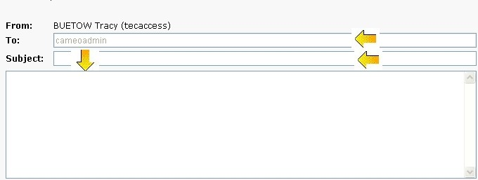
The Text Edit boxes and the Text Area box and the disabled “To” field

1194.22(n) When electronic forms are designed to be completed on-line, the form shall allow people using assistive technology to access the information, field elements, and functionality required for completion and submission of the form, including all directions and cues.
The form elements on the page do not have explicit labels. The text area for the message has no label. And the “To” field is disabled.

Recommendations
Add explicit labeling using the Label For syntax to all fields. This includes the message filed, which should have a visible and associated label for clarity.
The disabling of the “To” field does not allow for screen reader users to review the contents of the field while tabbing. Setting the field to read-only would be better since the field is not meant to be edited.

WCAG Checkpoints

Checkpoint 1.1 (Priority 1) applies, comparable to 1194.22(a) above.

Checkpoint 12.4 (Priority 1) applies, comparable to 1194.22(n) above.

Cameo Student Logout Page

Test Results

The logout page was found to be accessible and compliant with Section 508 and the WCAG.

Current Learning Modules

Section 508

1194.22(i) Frames shall be titled with text that facilitates frame identification and navigation.
Reference Site Wide Issues.

WCAG Checkpoints

Checkpoint 12.1 (Priority 1) applies, comparable to 1194.22(i) above.

My Training
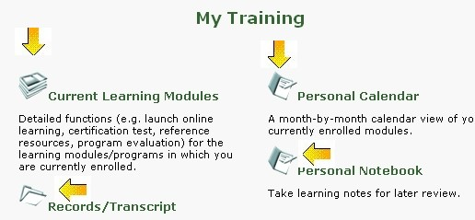
The images beside the links of “Current Learning Modules,” “Personal Calendar,” “Records/Transcripts” and “Personal Notebook”

Section 508

1194.22(a) A text equivalent for every non-text element shall be provided (e.g., via "alt", "longdesc", or in element content).
The images beside the links of “Current Learning Modules,” “Personal Calendar,” “Records/Transcripts” and “Personal Notebook” all have Alt text attributes. However, the images are included as part of the actual display of their associated links, and thus can be viewed as decoration.

Recommendation
Since these graphics are the same as the text that is already being displayed, assigning empty Alt attributes to these graphics would be preferable and enhance the usability for screen reader users. This is because in the current form, moving to one of these links causes the screen reader to read the link twice; once, because it is reading the associated image’s Alt attribute text, and the second time, when it reads the display text of the link itself.

WCAG Checkpoints

Checkpoint 1.1 (Priority 1) applies, comparable to 1194.22(a) above.

Records/Transcripts
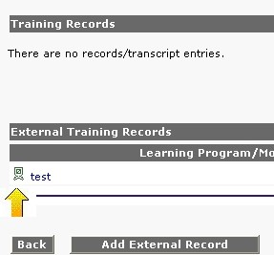
The image “catalog_external.gif”

Section 508

1194.22(a) A text equivalent for every non-text element shall be provided (e.g., via "alt", "longdesc", or in element content).
The image catalog_external.gif that displays in the external table when there is a record does not have an alt attribute.

Recommendation
If the graphic is purposeful, assign an equivalent Alt attribute. If the graphic is for decoration only, then assign an empty Alt attribute.

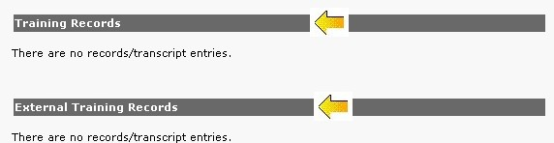

The “Training Record” and “External Training Record” labels.

1194.22(d) Documents shall be organized so they are readable without requiring an associated style sheet.
Headings for “Training Record” and “External Training Record” do not have heading tags.

Recommendation
Encapsulate the noted headings with heading tags such as H1, H2 or similar.

WCAG Checkpoints

Checkpoint 1.1 (Priority 1) applies, comparable to 1194.22(a) above.

Checkpoint 3.5 (Priority 2) applies, comparable to 1194.22(d) above.

Add External Record
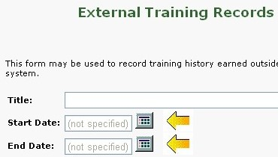
The “cx_calendar.gif” images

Section 508

1194.22(a) A text equivalent for every non-text element shall be provided (e.g., via "alt", "longdesc", or in element content).
The calendar image “cx_calendar.gif” does not have an Alt attribute. This causes for screen reader users to not know what the graphical link is for.

Recommendation
Add an Alt attribute, e.g., “Calendar.”

1194.22(n) When electronic forms are designed to be completed on-line, the form shall allow people using assistive technology to access the information, field elements, and functionality required for completion and submission of the form, including all directions and cues.
See Site Wide Issues as the form on this page is similar to the other forms on the website.

WCAG Checkpoints

Checkpoint 1.1 (Priority 1) applies, comparable to 1194.22(a) above.

Checkpoint 12.4 (Priority 2) applies, comparable to 1194.22(n) above.

Personal Calendar
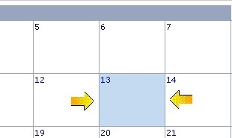
Light blue coloring

Section 508

1194.22(c) Web pages shall be designed so that all information conveyed with color is also available without color, for example from context or markup.
In the calendar area, light blue coloring is used to indicate the current day. There is not a text equivalent for this information.

Recommendation
Add a text equivalent for the current date. For example, place an asterisk (*) beside the date.

The column headings

1194.22(g) Row and column headers shall be identified for data tables.
The column headings of the table lack heading markup (TH tags).

Recommendation
Add TH tags to the column headings, which are the names of the days of the week, and place this row inside of a THEAD tag.

WCAG Checkpoints

Checkpoint 2.1 (Priority 1) applies, comparable to 1194.22(c) above.

Checkpoint 5.1 (Priority 1) applies, comparable to 1194.22(g) above.

Personal Notebook
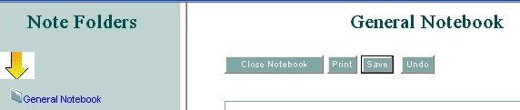
The “folder2.gif”

Section 508

1194.22(a) A text equivalent for every non-text element shall be provided (e.g., via "alt", "longdesc", or in element content).
The image folder2.gif which is on the left of the “General Notebook” link does not have an Alt attribute.

Recommendation
Since the folder2.gif graphic is for decoration, and there is a link beside it with same meaning, this graphic should be assigned an empty Alt text attribute.
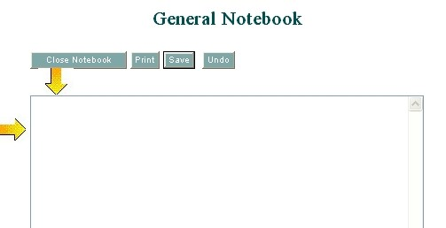
The text area

1194.22(n) When electronic forms are designed to be completed on-line, the form shall allow people using assistive technology to access the information, field elements, and functionality required for completion and submission of the form, including all directions and cues.
The buttons are all accessible. The text area does not have a label, which would be helpful. See Site Wide Issues.

WCAG Checkpoints

Checkpoint 1.1 (Priority 1) applies, comparable to 1194.22(a) above.

Checkpoint 12.4 (Priority 2) applies, comparable to 1194.22(n) above.

Catalog/Search
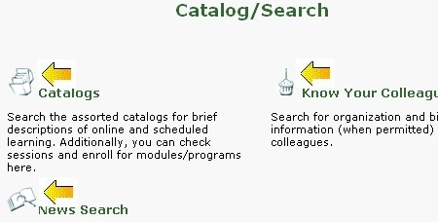
Graphics called “Catalogs,” “Know Your Colleagues” and “News Search”.

Section 508

1194.22(a) A text equivalent for every non-text element shall be provided (e.g., via "alt", "longdesc", or in element content).
The graphics alongside the links “Catalogs,” “Know Your Colleagues” and “News Search” do have Alt attributes, but since they are joined with the display text of the link, they are decorative.

Recommendation
Assigning the graphics empty Alt attribute will keep screen readers from double-reading the link when they are tabbed too.

WCAG Checkpoints

Checkpoint 1.1 (Priority 1) applies, comparable to 1194.22(a) above.

Catalogs Page
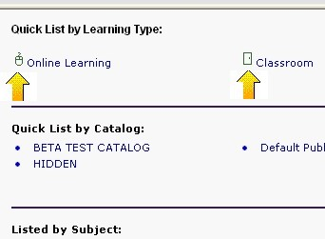
The images called “catalog_online.gif” and “catalog_classroom.gif”.

Section 508

1194.22(a) A text equivalent for every non-text element shall be provided (e.g., via "alt", "longdesc", or in element content).
The images catalog_online.gif and catalog_classroom.gif have Alt attributes assigned; however, these are decorative images.

Recommendation
Assign empty Alt attributes (ALT=””) to these images.

The heading “Search Catalog”.

1194.22(d) Documents shall be organized so they are readable without requiring an associated style sheet.
The headings “Search Catalog” and the other categorizing headings do not have heading tags.

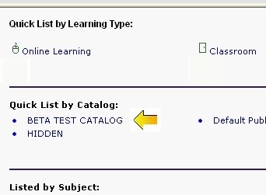
The “Beta Test Catalog” link

Below the “Quick List by Catalog” heading, the “Beta Test Catalog” link is broken; it appears as if the “</a>” may be missing. The link URL is showing to JAWS and the text is showing separate and not as a link. This is also breaking the list element.
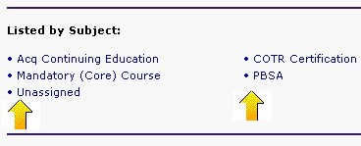
The links below “Listed by Subject”

The links below “Listed by Subject” are not grouped in a list element.

Recommendations
Add heading tags such as an H1 to all the headings on the page.
Under “Quick List by Catalog” correct the HTML errors. The use of a list element is good and should be kept.
Add a list element to group the links that are associated with “Listed by Subject.”

The search edit field at the top of the page.

1194.22(n) When electronic forms are designed to be completed on-line, the form shall allow people using assistive technology to access the information, field elements, and functionality required for completion and submission of the form, including all directions and cues.
The search edit field at the top of the page does not have a label.

Recommendation
Give the field a label. The heading text of “Search Catalog” is already present; it could be linked to the edit field via an explicit label.

WCAG Checkpoints

Checkpoint 1.1 (Priority 1) applies, comparable to 1194.22(a) above.

Checkpoint 3.5 (Priority 2) applies, comparable to 1194.22(d) above.

Checkpoint 3.6 (Priority 2) applies, comparable to the notes about lists in 1194.22(d) above.

Checkpoint 12.4 (Priority 2) applies, comparable to 1194.22(n) above.

Default Public Catalog
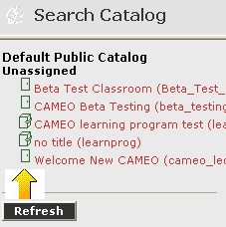
The graphics alongside “Beta Test Classroom (Beta_Test_Class),” “CAMEO Beta Testing (beta_testing),” “CAMEO learning program test (learning program)” and “no title (learnprog)”.

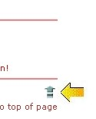
The image “arrow10.gif”

Section 508

1194.22(a) A text equivalent for every non-text element shall be provided (e.g., via "alt", "longdesc", or in element content).
The graphics alongside “Beta Test Classroom (Beta_Test_Class),” “CAMEO Beta Testing (beta_testing),” “CAMEO learning program test (learning program)” and “no title (learnprog)” lack Alt text attributes. Additionally the images CAM100003611.bmp and arrow10.gif do not have Alt attributes.

Recommendation
These graphics beside the links are decorative and thus should be assigned empty Alt attributes. If this is meant to look like a list of items, then encapsulating the links inside a list element would be either a better alternative to the graphics, or a good addition.

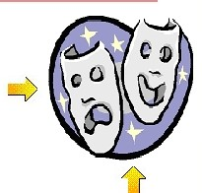
After choosing the “Beta Test Classroom” link, the “CAM100003611.bmp”

The image CAM100003611.bmp is decorative in nature. Thus it should be assigned an empty Alt attribute (ALT=””).

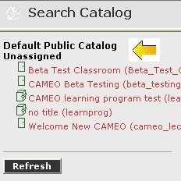
The text “Default Public Catalog – Unassigned” in the left frame.

1194.22(d) Documents shall be organized so they are readable without requiring an associated style sheet.
The text “Default Public Catalog – Unassigned” in the left frame is a heading, but lacks heading tags. Additionally there are other headings scattered throughout this page that lack heading tags.

Recommendation
Add heading tags for all headings.

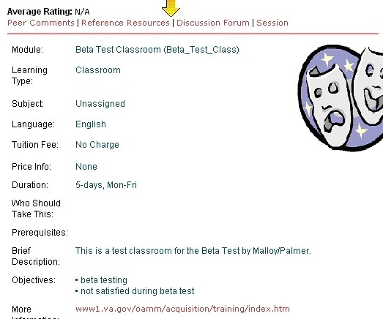
The Course Information table

1194.22(g) Row and column headers shall be identified for data tables.
The Course Information table is a data table. It lacks TH tags for its headings.

Recommendation
Add TH tags to the headings of the Course Information table because this is a data table.

WCAG Checkpoints

Checkpoint 1.1 (Priority 1) applies, comparable to 1194.22(a) above.

Checkpoint 3.5 (Priority 2) applies, comparable to 1194.22(d) above.

Checkpoint 5.1 (Priority 1) applies, comparable to 1194.22(g) above.

News Search
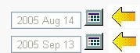
The calendar icons “cx_calendar.gif”

Section 508

1194.22(a) A text equivalent for every non-text element shall be provided (e.g., via "alt", "longdesc", or in element content).
The calendar icons, cx_calendar.gif do not have Alt text attributes.

Recommendation
Add Alt attributes for these graphical links.

1194.22(n) When electronic forms are designed to be completed on-line, the form shall allow people using assistive technology to access the information, field elements, and functionality required for completion and submission of the form, including all directions and cues.
Reference Site Wide Issues about forms

WCAG Checkpoints

Checkpoint 1.1 (Priority 1) applies, comparable to 1194.22(a) above.

Checkpoint 12.4 (Priority 2) applies, comparable to 1194.22(n) above.

Checkpoint 3.7 (Priority 2) Mark up quotations. Do not use quotation markup for formatting effects such as indentation.
A blockquote was used on the page for formatting, but not for actual quotation of text.

Recommendation
Remove the blockquote and use a styled paragraph to get the desired formatting effect.

Know Your Colleague
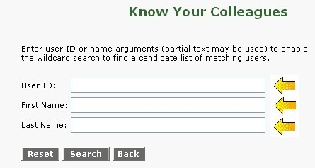
See Site Wide Issues for forms.

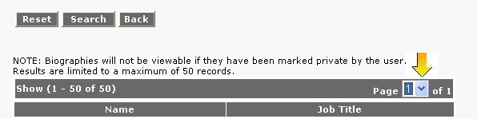
Search Results display contains a combo box.

Section 508

1194.22(n) When electronic forms are designed to be completed on-line, the form shall allow people using assistive technology to access the information, field elements, and functionality required for completion and submission of the form, including all directions and cues.
See Site Wide Issues for forms. Additionally note that the Search Results display contains a combo box that needs to be labeled also.

WCAG Checkpoints

Checkpoint 12.4 (Priority 2) applies, comparable to 1194.22(n) above.

Communicate
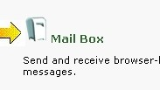
The graphic com_inmail.gif.

Section 508

1194.22(a) A text equivalent for every non-text element shall be provided (e.g., via "alt", "longdesc", or in element content).
The graphic com_inmail.gif has an Alt attribute, but this graphic is part of the Mailbox link and thus is decorative.

Recommendation
Give com_inmail.gif an empty Alt attribute so that screen readers will not double-read “mailbox” when the link is encountered.

WCAG Checkpoints

Checkpoint 1.1 (Priority 1) applies, comparable to 1194.22(a) above.

Discussion Forum
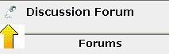
The images “forum.gif”

Section 508

1194.22(a) A text equivalent for every non-text element shall be provided (e.g., via "alt", "longdesc", or in element content).
The images forum.gif and a JavaScript type image (Javascript:void(0)” are present. Neither have alt attributes.

Recommendation
Add Alt attributes. If it is for decoration, use an empty Alt attribute. If it has a purpose, assign an equivalent Alt text attribute.

1194.22(d) Documents shall be organized so they are readable without requiring an associated style sheet.
Headings lack heading tags. In the Forum frame the heading is broken, having both an H2 and H3.

Recommendation
All headings, including the heading “Forums,” need to have heading tags. Do not nest headings inside of each other.

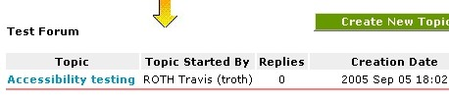
After choosing the “Test Forum” in the far left, the data table is in the far right.

1194.22(g) Row and column headers shall be identified for data tables.
The Test Forums table is a data table and does have TH tags. However, the headings are not in the first row of the table.

Recommendation
Make the column headings the first row of the table. Eitherplace the heading “Test forum” outside (above) the table, or make it a caption of the table.

1194.22(i) Frames shall be titled with text that facilitates frame identification and navigation.
Reference Site Wide Issues—all of these frames need titles.

1194.22(n) When electronic forms are designed to be completed on-line, the form shall allow people using assistive technology to access the information, field elements, and functionality required for completion and submission of the form, including all directions and cues.
Reference Site Wide Issues for forms

WCAG Checkpoints

Checkpoint 3.5 (Priority 2) applies, comparable to 1194.22(d) above.

Checkpoint 5.1 (Priority 1) applies, comparable to 1194.22(g) above.

Checkpoint 12.1 (Priority 1) applies, comparable to 1194.22(i) above.

Checkpoint 12.4 (Priority 2) applies, comparable to 1194.22(n) above.

Send A Message
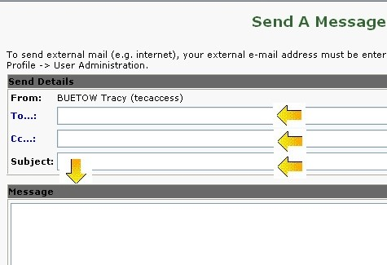
Form issues.

Section 508

1194.22(n) When electronic forms are designed to be completed on-line, the form shall allow people using assistive technology to access the information, field elements, and functionality required for completion and submission of the form, including all directions and cues.
Reference Site Wide Issues for forms

WCAG Checkpoints

Checkpoint 12.4 (Priority 2) applies, comparable to 1194.22(n) above.

Select To Recipients
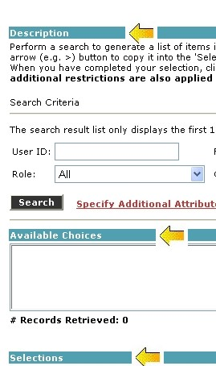
Headings.

Section 508

1194.22(d) Documents shall be organized so they are readable without requiring an associated style sheet.
Headings lack heading tags.

Recommendation
Add heading tags where applicable.

1194.22(n) When electronic forms are designed to be completed on-line, the form shall allow people using assistive technology to access the information, field elements, and functionality required for completion and submission of the form, including all directions and cues.
Reference Site Wide Issues for forms

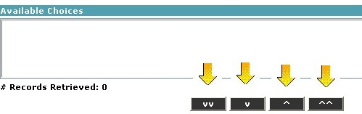
Buttons using arrows.

Additionally, the buttons on this page that look like arrows need actual text labels that are discernable to screen reader users. Captions such as “V” and “^^” do not make sense to screen reader users and they cannot determine the purpose or what will happen when the button is activated.
“User Selector Additional Attributes”: same form issues as the parent page, reference Site Wide Issues.
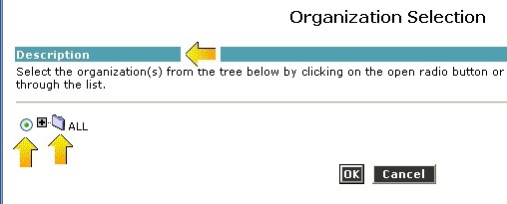
“Select” organization: same issues as parent, radio buttons need explicit labels. Reference the Site Wide Issues.

Recommendations
Follow Site Wide Issues’ recommendations for explicit labeling. And give the arrow buttons screen reader friendly names.

WCAG Checkpoints

Checkpoint 3.5 (Priority 2) applies, comparable to 1194.22(d) above.

Checkpoint 12.4 (Priority 2) applies, comparable to 1194.22(n) above.

Mailbox
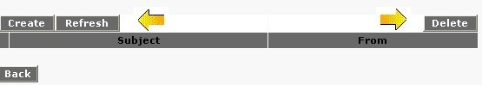
Buttons in the table

Section 508

1194.22(g) Row and column headers shall be identified for data tables.
The mail table does have TH tags, which is good. However, there are buttons in the first row of the table.

Recommendation
Move the buttons outside of the table. Use the table for only displaying the messages.

1194.22(n) When electronic forms are designed to be completed on-line, the form shall allow people using assistive technology to access the information, field elements, and functionality required for completion and submission of the form, including all directions and cues.
Reference Site Wide Issues

WCAG Checkpoints

Checkpoint 5.1 (Priority 1) applies, comparable to 1194.22(g) above.

Checkpoint 12.4 (Priority 2) applies, comparable to 1194.22(n) above.

Personal Profile
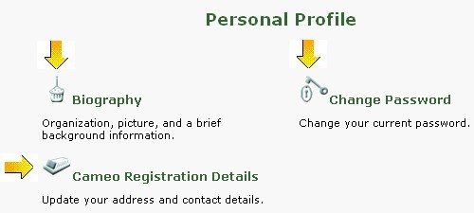
The graphics beside the links “Biography,” “Change Password” and “Cameo Registration Details”

Section 508

1194.22(a) A text equivalent for every non-text element shall be provided (e.g., via "alt", "longdesc", or in element content).
The graphics beside the links “Biography,” “Change Password” and “Cameo Registration Details” have Alt text attributes containing text, but the graphics are decorative.

Recommendation
Since these graphics are decorative and their meaning is also available in the text link they are part of, empty Alt attributes should be used. This gives the added benefit of screen readers not double-reading the link’s destination.

WCAG Checkpoints

Checkpoint 1.1 (Priority 1) applies, comparable to 1194.22(a) above.

Biography
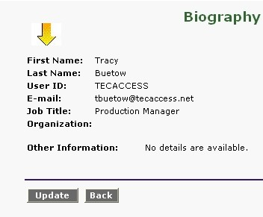
The data table on the main page.

Section 508

1194.22(g) Row and column headers shall be identified for data tables.
The data table on the main page lacks TH tags.

Recommendation
Add TH tags for the headings, which are in the left-hand column.

1194.22(n) When electronic forms are designed to be completed on-line, the form shall allow people using assistive technology to access the information, field elements, and functionality required for completion and submission of the form, including all directions and cues.
Reference Site Wide Issues.

WCAG Checkpoints

Checkpoint 12.4 (Priority 2) applies, comparable to 1194.22(n) above.

Change Password
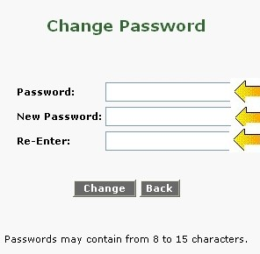
Reference Site-Wide Issues.

Section 508

1194.22(n) When electronic forms are designed to be completed on-line, the form shall allow people using assistive technology to access the information, field elements, and functionality required for completion and submission of the form, including all directions and cues.
Reference Site Wide Issues

WCAG Checkpoints

Checkpoint 12.4 (Priority 2) applies, comparable to 1194.22(n) above.

VPAT

Supporting Features (second column on VPAT)
Supports | Use this language when you determine the product fully meets the letter and intent of the Criteria.
Supports with Exceptions | Use this language when you have determined that the product does not fully meet the letter and intent of the Criteria, but provides some level of access relative to the Criteria.
Supports through Equivalent Facilitation | Use this language when you have identified an alternate way to meet the intent of the Criteria or when the product does not fully meet the intent of the Criteria.
Supports when combined with Compatible AT | Use this language when you have determined that the product fully meets the letter and intent of the Criteria when used in combination with Compatible AT. For example, many software programs can provide speech output when combined with a compatible screen reader (commonly used assistive technology for people who are blind).
Does not Support | Use this language when you have determined that the product does not meet the letter or intent of the Criteria.
Not Applicable | Use this language when you have determined that the Criteria do not apply to the specific product.
Not Applicable - Fundamental Alteration Exception Applies | Use this language when you have determined that a Fundamental Alteration of the product would be required to meet the Criteria (see the access board standards for the definition of "fundamental alteration").

1194.22 Web-based Internet information and applications
Criteria | Supporting Features | Remarks and explanations
(a) A text equivalent for every non-text element shall be provided (e.g., via "alt", "longdesc", or in element content). | Supports with exceptions | Most images do have Alt attributes assigned. Some functional images do not, and some buttons have uninformative text that does not help screen readers. Also, some images are decorative in nature and their assigned alt attributes are extra and should be replaced with empty Alt attributes.
(b) Equivalent alternatives for any multimedia presentation shall be synchronized with the presentation. | N/A
(c) Web pages shall be designed so that all information conveyed with color is also available without color, for example, from context or markup. | Supports with exceptions | An instance of color coding was found in the Calendar, where color was used to indicate the current day’s date.
(d) Documents shall be organized so they are readable without requiring an associated style sheet. | Supports with exceptions | Information is in a logical order when style sheets are disabled or unsupported. Some structural markups, such as heading tags for text headings and column headings in data tables, are missing. The use of user-defined style sheets was supported.
(e) Redundant text links shall be provided for each active region of a server-side image map. | N/A
(f) Client-side image maps shall be provided instead of server-side image maps except where the regions cannot be defined with an available geometric shape. | N/A
(g) Row and column headers shall be identified for data tables. | Supports with Exceptions | Most data tables have heading markup (TH tags). However, some do not, and many of the tables do not have the headings on the first row of the table.
(h) Markup shall be used to associate data cells and header cells for data tables that have two or more logical levels of row or column headers. | N/A | No tables with two or more logical levels were found.
(i) Frames shall be titled with text that facilitates frame identification and navigation | Supports with exceptions | Some frames have title tags. Most of these are generic and not descriptive of the exact location. Additionally, all frames lack a Title attribute, which is what screen readers prefer to use for frame identification.
(j) Pages shall be designed to avoid causing the screen to flicker with a frequency greater than 2 Hz and lower than 55 Hz. | Supports
(k) A text-only page, with equivalent information or functionality, shall be provided to make a web site comply with the provisions of this part, when compliance cannot be accomplished in any other way. The content of the text-only page shall be updated whenever the primary page changes. | N/A
(l) When pages utilize scripting languages to display content, or to create interface elements, the information provided by the script shall be identified with functional text that can be read by Assistive Technology. | Supports
(m) When a web page requires that an applet, plug-in or other application be present on the client system to interpret page content, the page must provide a link to a plug-in or applet that complies with §1194.21(a) through (l). | N/A | No plug-in requirements were detected.
(n) When electronic forms are designed to be completed on-line, the form shall allow people using Assistive Technology to access the information, field elements, and functionality required for completion and submission of the form, including all directions and cues. | Supports with exceptions | Explicit labeling of form input elements is not present. Implicit association of labels with controls is possible for most controls, but not all. Also, on the Mail Creation/Composition page, the buttons for selecting a recipient are not screen reader friendly – screen reader users do not understand what a “V” or “VV” is supposed to mean.
(o) A method shall be provided that permits users to skip repetitive navigation links. | Supports with exceptions | Navigational links are present on the screen, in the form of a navigational frame. It is possible to skip this frame with browser-supported methods. However, an actual “skip nav” link is not present. One should be placed in the left top navigation frame.
(p) When a timed response is required, the user shall be alerted and given sufficient time to indicate more time is required. | Supports

The Worldwide Web Consortium (W3C)
Side by Side WCAG vs. 508, sponsored by the Association of Tech Act Projects, at http://www.jimthatcher.com/sidebyside.htm

